

CS-3001

Network Security

ASSIGNMENT 01

Submitted by: Sarita Sangrez and Amna Ali
Roll number: 23i-2088 and 23i-2067
Date: 3rd October 2025

Part 1: Network Topology

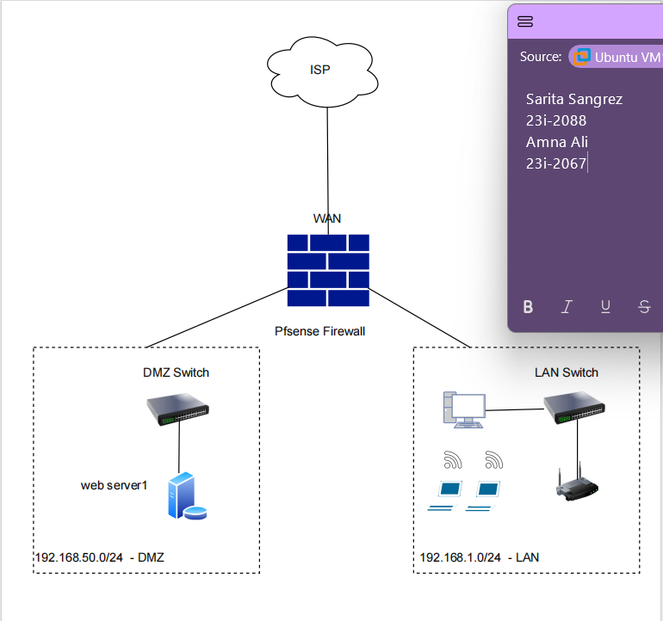

Pfsense Configuration Steps

- Initial Setup
pfSense was installed and network interfaces were assigned. The WAN interface was configured with IP 192.168.10.1/24 (connected to VMnet8 – NAT), the LAN interface was configured with IP 192.168.1.1/24 (connected to VMnet1 – Host-Only), and the DMZ interface (OPT1) was configured with IP 192.168.50.1/24 (connected to VMnet2 – Host-Only). Connectivity was verified by pinging between pfSense and client VMs.

- DHCP Configuration
The DHCP server was enabled on the LAN network with a range of 192.168.1.100 – 192.168.1.200 to dynamically assign IP addresses to client VMs. Similarly, a DHCP range of 192.168.50.100 – 192.168.50.200 was configured for the DMZ interface so the web server could receive a static or reserved address. The DNS resolver was enabled to ensure that clients could resolve domains even before authentication.

- LAN Firewall Rules
Several firewall rules were configured on the LAN interface. The default anti-lockout rule allowed HTTPS/SSH access to pfSense itself. A rule was created to permit DNS queries (UDP port 53) for clients. Additional rules were added to allow HTTP and HTTPS traffic but restricted to an alias list of specific websites. ICMP traffic was allowed with a rate limit to prevent flooding. Finally, rules were defined to allow SSH and HTTP access to the DMZ server for administration and web testing, while an explicit block rule was placed to deny all other unwanted traffic.

- WAN Firewall Rules
By default, pfSense blocks all unsolicited inbound connections on the WAN. To make the DMZ web server accessible from the Internet, port forwarding rules were created. Incoming WAN traffic on ports 80 (HTTP) and 443 (HTTPS) was forwarded to the DMZ web server’s IP address. This configuration allowed external users to access the web server while maintaining firewall protection.

- DMZ Firewall Rules
On the DMZ interface, specific rules were created to allow HTTP and HTTPS traffic from the WAN to the DMZ server. Outbound rules were also added to allow DNS (53), ICMP, and NTP (123) from the DMZ to the WAN. Access from the LAN to the DMZ was mostly blocked, except for ICMP (for testing), SSH (for administration), and HTTP (to access the hosted web service). This ensured strong isolation while still allowing necessary services.

- Captive Portal Configuration
A Captive Portal was enabled on the LAN1 network (192.168.1.0/24). Local user accounts were created for authentication. When a client attempted to browse the Internet, they were redirected to the login page until credentials were entered. Firewall exceptions were configured to allow DHCP (ports 67 and 68) and DNS (port 53) traffic even before login. After successful authentication, clients were able to browse the Internet and access resources in the DMZ.

Part 2: PfSense Configuration with basic rules implementation

Network Setup

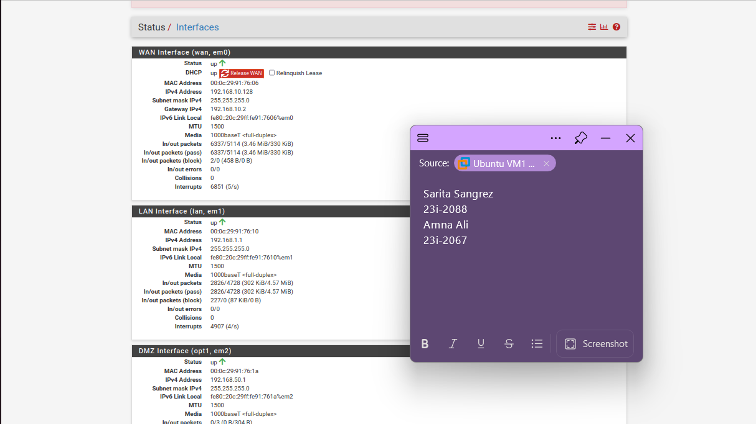

Firewall Rules
PfSense processes firewall rules in a top-down order. The first matching rule is applied, and subsequent rules are ignored.

LAN Rules (evaluated top-down)
- Allow LAN clients (192.168.1.0/24) to access DNS (53) on any destination.
- Allow LAN clients to access HTTP (80) on any destination.
- Allow LAN clients to access HTTPS (443) on any destination.
- Allow LAN clients to send ICMP (ping) to the DMZ.
- Allow LAN clients to use SSH (22) to the DMZ.
- Block all other LAN to DMZ traffic.

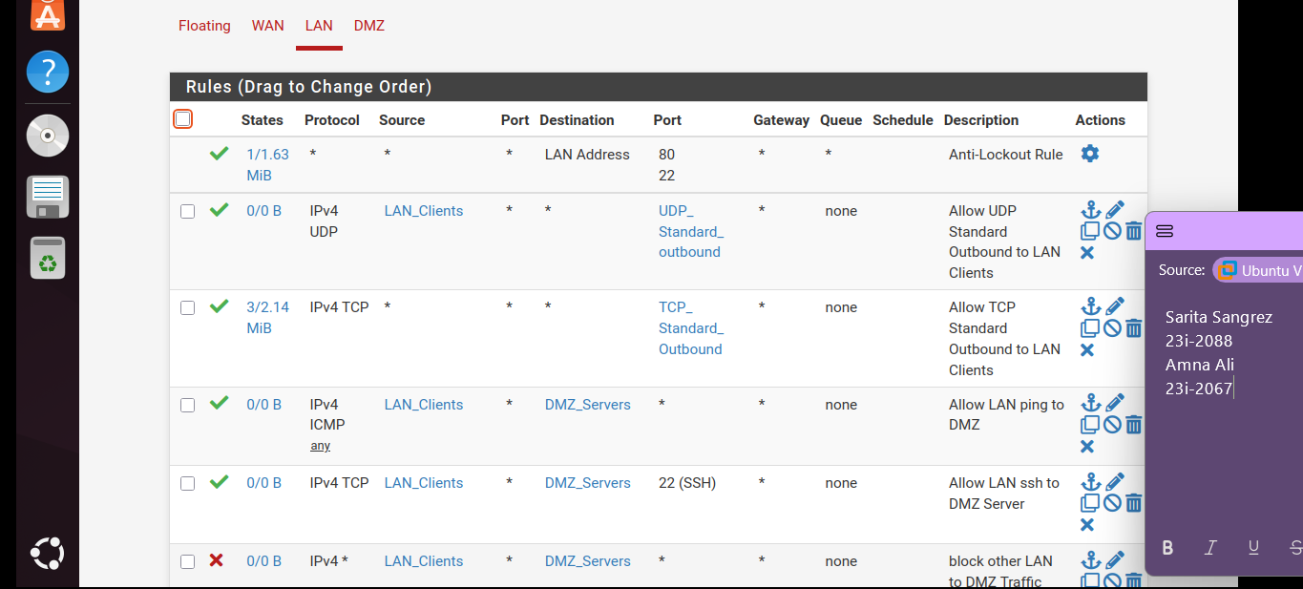

DMZ Rules (evaluated top-down)
- Allow DMZ server alias to use DNS (53) to any destination.
- Allow DMZ server alias to send ICMP (ping) to any destination.
- Allow DMZ server alias to use NTP (123) to any destination.
- Block all other DMZ to WAN traffic.

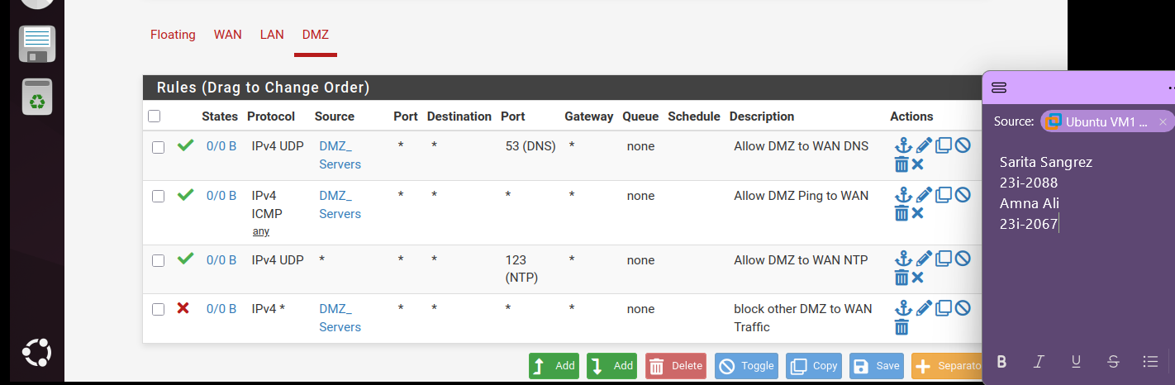

Part 3: Suricata Installation and Configuration

Suricata Configuration Steps

- Suricata Installation
Suricata was installed on pfSense as a package using the pfSense Package Manager. After installation, the Suricata service appeared under the Services menu, and the configuration dashboard allowed assigning Suricata to different network interfaces.

- Interface Selection
Suricata was enabled on the WAN, DMZ, and LAN interfaces. Running Suricata on the WAN allowed detection of inbound scans and attacks from the Internet, while running it on the LAN enabled monitoring of internal activity, such as suspicious connections or malware traffic originating from clients.

- Ruleset Configuration
The Emerging Threats Open ruleset was downloaded and activated. Categories such as Malware, DNS, SSH, and Policy were enabled for testing. This allowed Suricata to detect common scanning attempts, DNS anomalies, malware signatures, and unauthorized protocols.

- Custom Rules
In addition to the prebuilt rules, a custom ICMP rule was created to trigger an alert whenever a ping request was sent from the Kali Linux VM to the Ubuntu LAN client. This confirmed that Suricata was correctly processing traffic and generating alerts.

- Alert Testing on WAN
To test Suricata on the WAN, an Nmap port scan was run from the Kali VM targeting the LAN client. Suricata successfully generated alerts showing a TCP SYN scan attempt. These alerts provided details about the source IP, destination IP, and the ports being probed.

- Alert Testing on LAN
On the LAN interface, the custom ICMP rule triggered successfully when ping traffic was sent between the Kali VM and the Ubuntu LAN client. This verified that Suricata could monitor internal client activity. Later, DNS-related rules were enabled, and attempts to make DNS queries also triggered alerts under the LAN interface.

- Logging and Alert Review. Each alert provided information about the rule triggered, source/destination IP, and the type of threat. For example, the Nmap scan was flagged as a portscan attempt, while the ICMP test rule was logged as an explicit “ICMP TEST ALERT.”

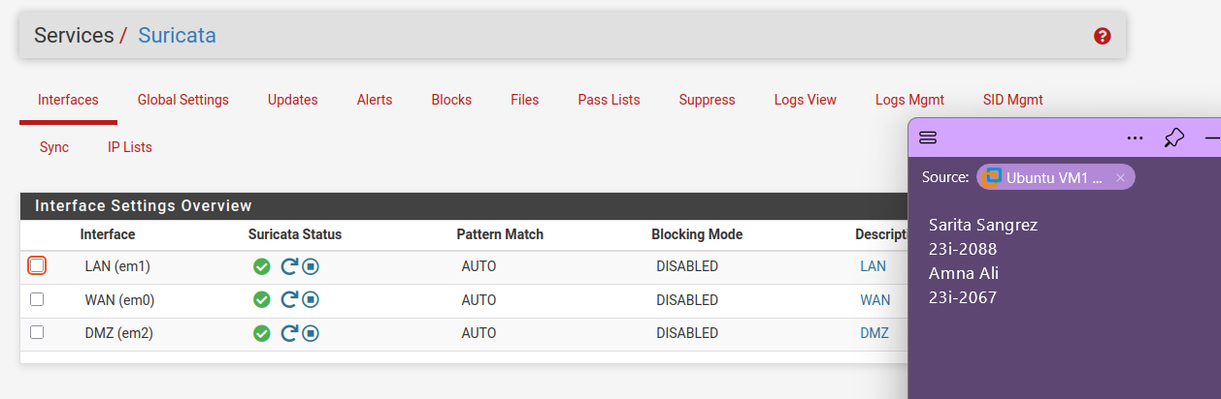
Suricata Alerts and Their Significance

- Nmap Scan on WAN Interface
  - Alert Example: Suricata generated alerts when a port scan was performed from the Kali machine targeting the WAN IP of pfSense. The alert was triggered by the Emerging Threats Scan Detection ruleset.
  - Significance: This shows Suricata’s ability to detect reconnaissance attempts, which are often used by attackers to discover open ports and services before launching targeted exploits.

- ICMP Custom Rule on LAN Interface
  - Alert Example: A custom ICMP rule was added to Suricata for LAN monitoring. When a ping was sent from Kali to the Ubuntu LAN client, the alert was logged.
  - Significance: Confirms that Suricata is functioning properly on the LAN side and demonstrates the flexibility of custom rules for specific monitoring needs.

- DNS Query to Suspicious Domain (LAN Interface)
  - Alert Example: Suricata’s Emerging DNS rules can generate alerts when LAN clients attempt to resolve known malicious or suspicious domains (for example, domains used by malware or command-and-control servers).
  - Significance: Detecting suspicious DNS traffic helps identify infected clients trying to communicate with external malicious infrastructure. Even if the domain cannot be reached, the DNS request itself is enough to raise an alert.

- Malware Signature Attempt (WAN Interface)
  - Alert Example: Suricata rules include signatures for common malware downloads, such as the EICAR test file. If a LAN client downloads or transfers this file through the WAN, Suricata generates a malware alert.
  - Significance: This simulates real-world malware detection. It proves that Suricata can recognize and block files matching known malware signatures before they enter the protected network.

- Telnet Traffic (LAN to WAN)
  - Alert Example: When the Emerging Telnet ruleset is enabled, Suricata can trigger alerts on any attempts to use insecure Telnet sessions.
  - Significance: Telnet is an outdated and insecure protocol. Detecting and logging it ensures administrators can prevent unsafe communication inside or outside the LAN.

Testing on WAN Interface

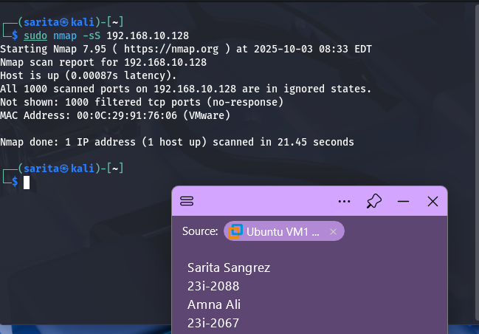

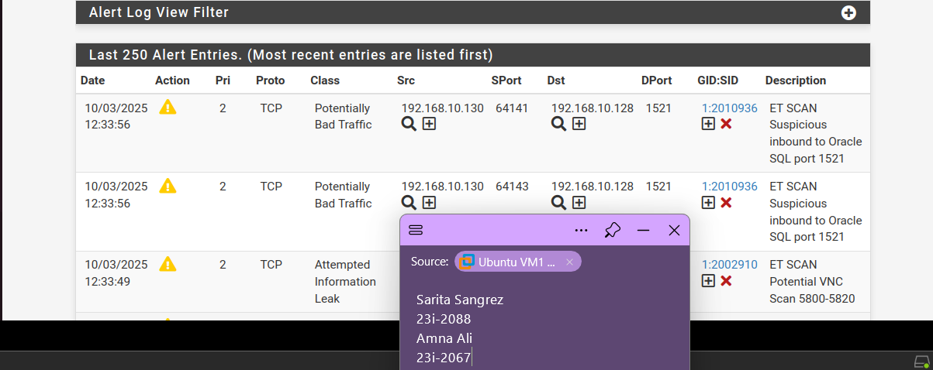

Testing on LAN Interface

No alerts were shown using nmap and telnet commands, so they were generated through a custom rule:

alert icmp any any -> any any (msg:"LAN ICMP Test"; sid:1000001; rev:1;)

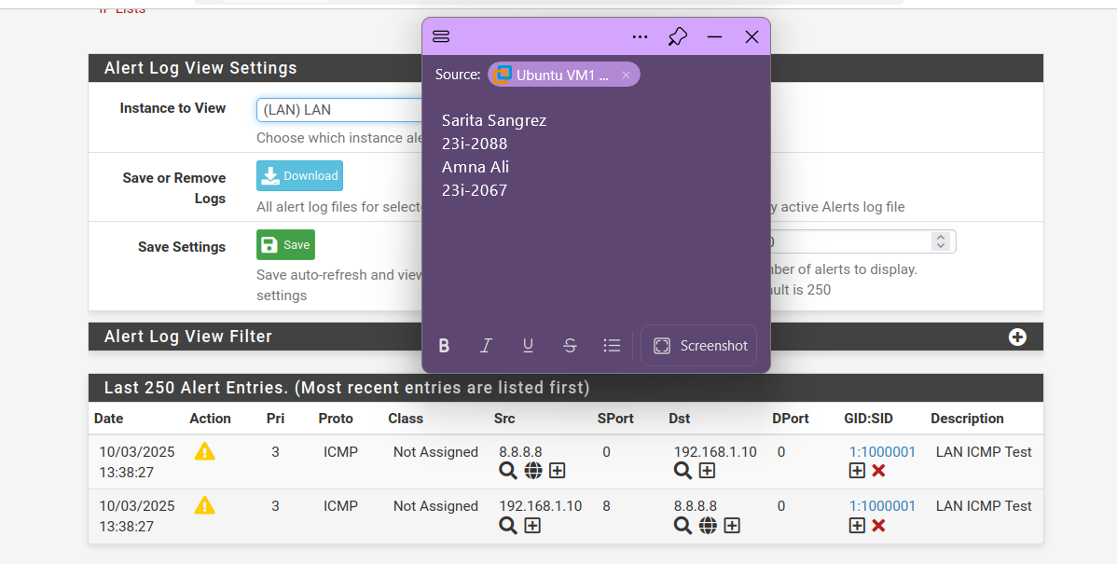

Part 4: DMZ Configuration

DMZ Configuration Steps

- DMZ Interface Setup
A separate interface was created in pfSense for the DMZ by assigning the VMnet2 adapter. The network was configured with the address range 192.168.50.0/24, providing clear separation from the LAN (192.168.1.0/24) and WAN (192.168.10.0/24) networks. The pfSense firewall was assigned the static gateway IP 192.168.50.1 for the DMZ interface.

- Static IP for Web Server
Within the DMZ, the Nginx web server was deployed with the static IP address 192.168.50.10. This ensured consistent addressing and made the server reachable for NAT port forwarding and firewall rule creation. Other devices in the DMZ could use DHCP if required, but static addressing was chosen for the web server to avoid conflicts.

- Firewall Rules
By default, no traffic was permitted between the DMZ, WAN, and LAN. Specific firewall rules were created to allow inbound HTTP and HTTPS traffic from the WAN to the Nginx server (192.168.50.10). Outbound traffic from the DMZ to the internet was restricted only to essential services, minimizing exposure to external threats. Additional rules were applied to block all direct communication between the DMZ and the LAN, ensuring strong segmentation.

- NAT Port Forwarding
To make the Nginx web service accessible to external clients, NAT port forwarding was configured. Requests arriving at the WAN IP on ports 80 (HTTP) and 443 (HTTPS) were forwarded to the internal IP 192.168.50.10 in the DMZ. This enabled external users to access the hosted website while keeping the server isolated from the LAN.

Port Forwarding on NAT

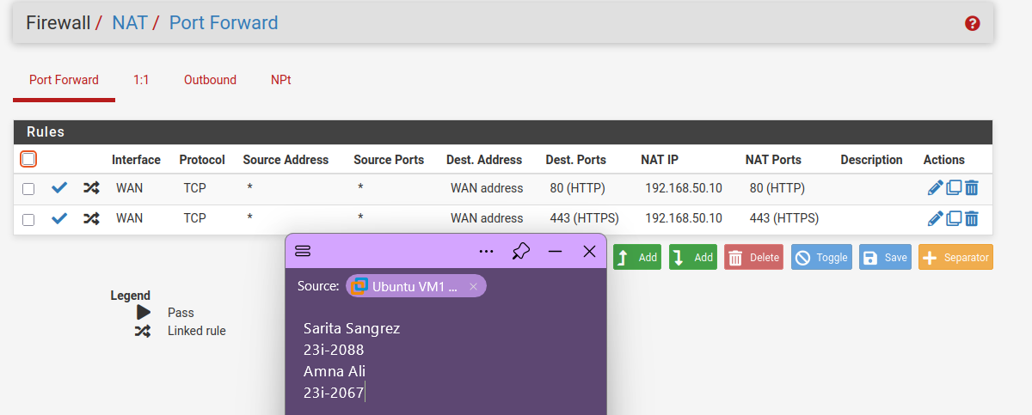

Firewall Rules on LAN

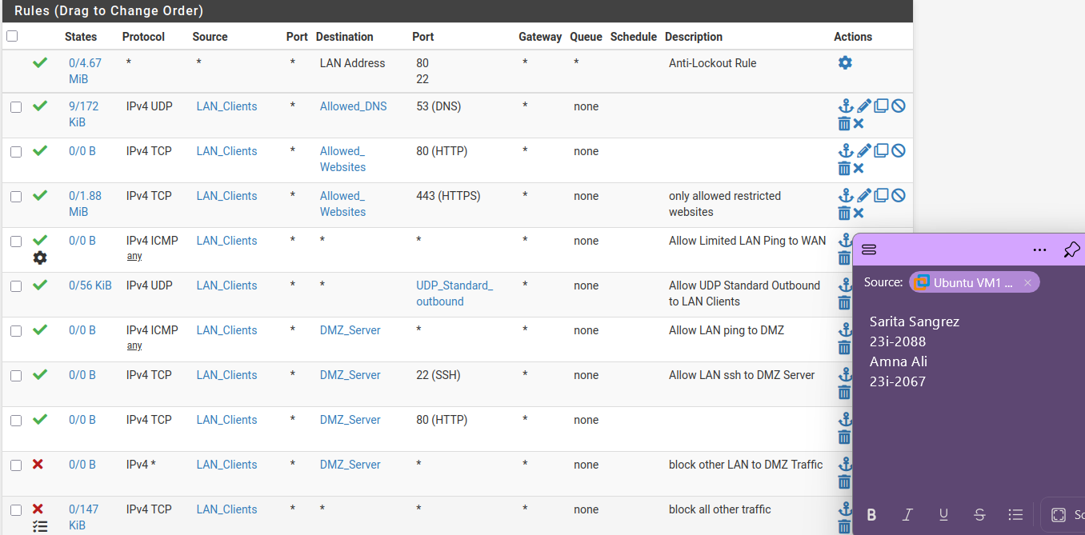

Firewall Rules on DMZ

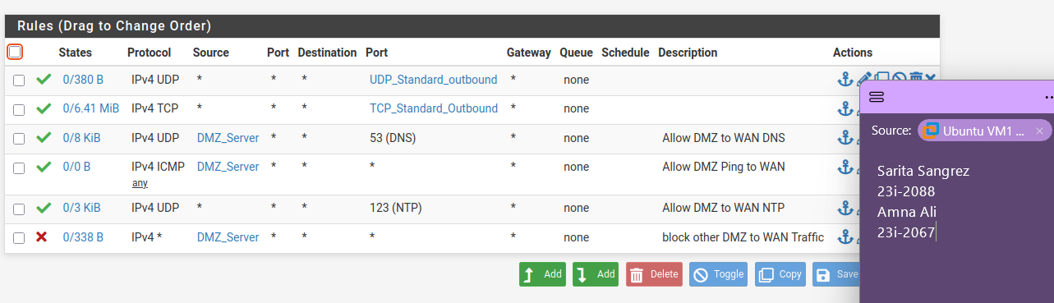

Firewall Rules on WAN

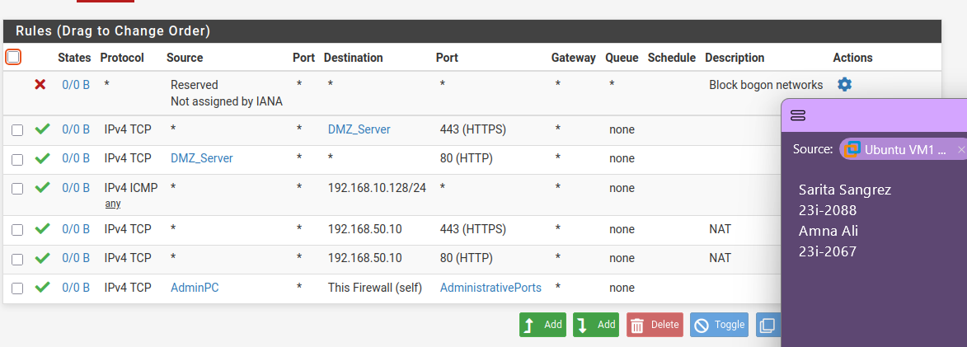

Nginx Installation and Configuration on DMZ

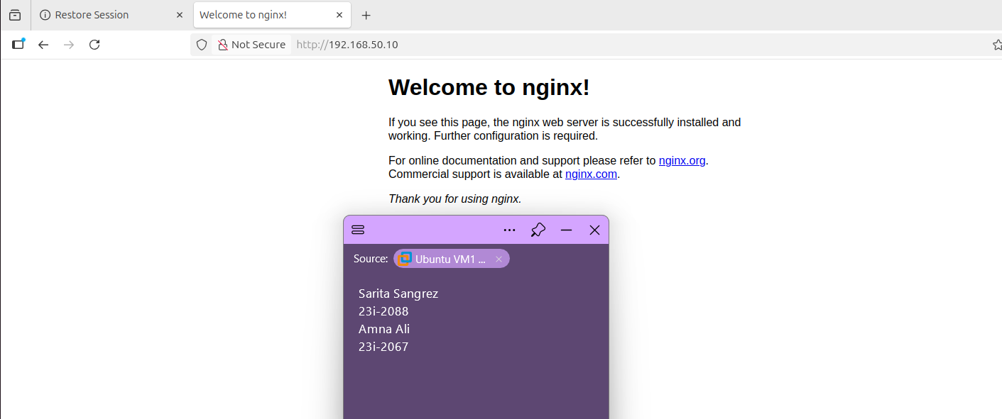

Port Forward in pfSense: WAN :8080 -> LAN

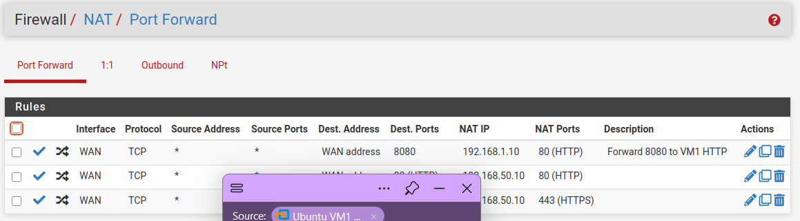

Test from VM2 (On WAN)

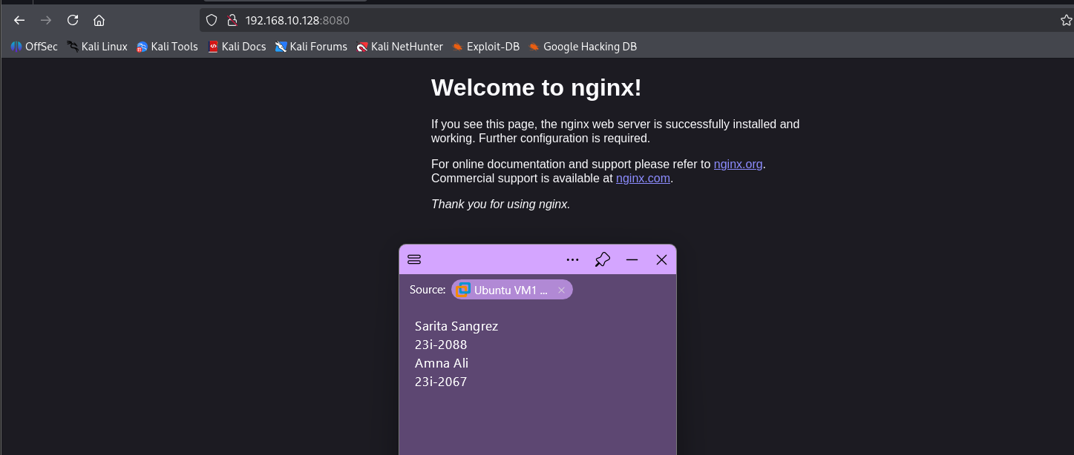

Verify traffic is forwarded

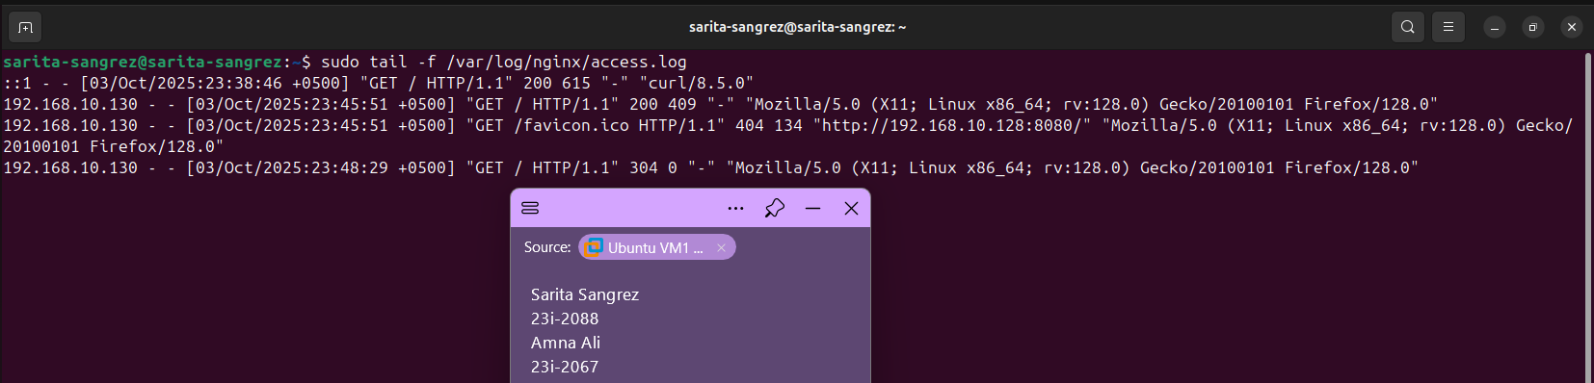

Part 5: Enable Captive Portal on LAN1

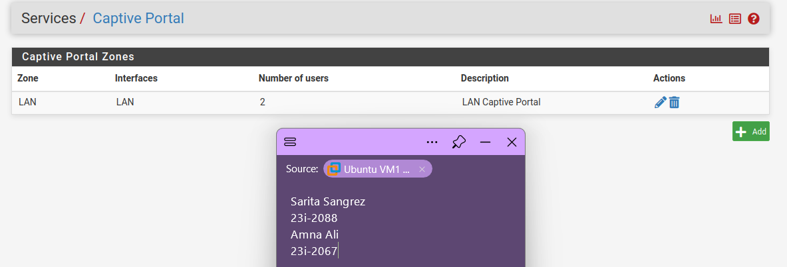

On my Static IP VM

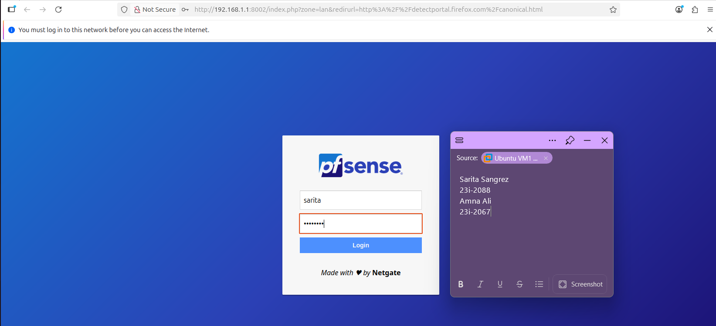

On my DHCP VM

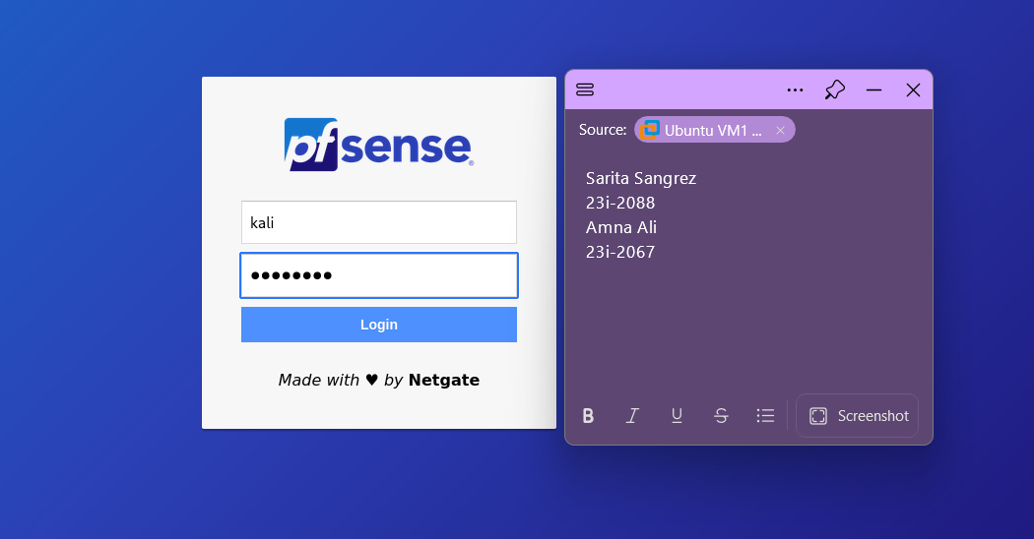

Accessing Nginx without Authentication

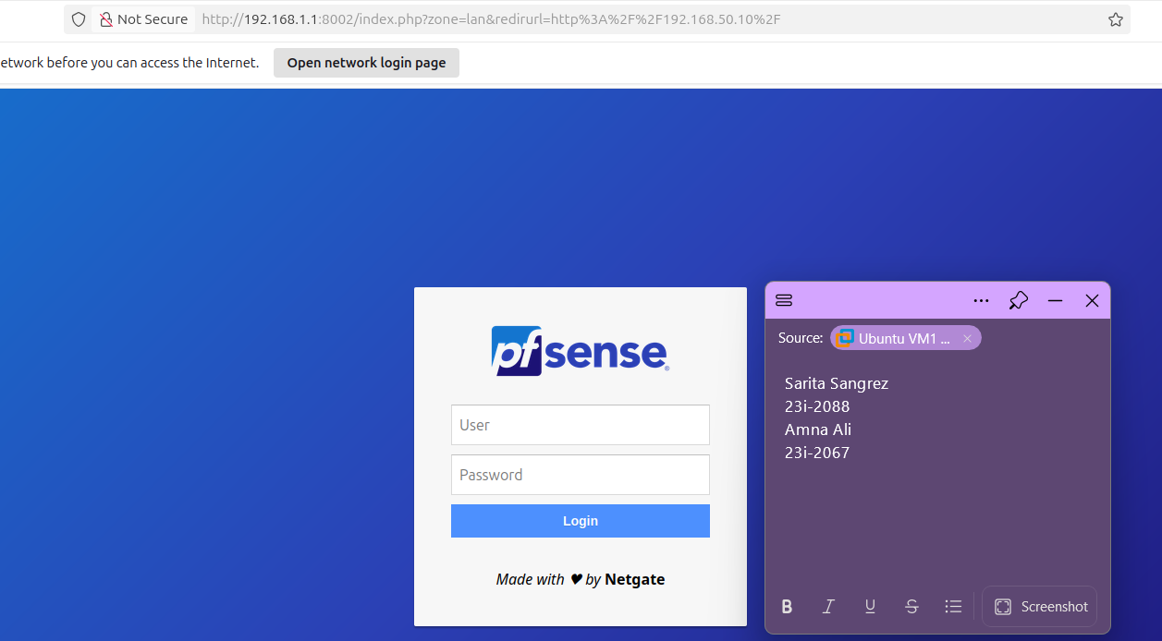

Accessing Nginx After Authentication

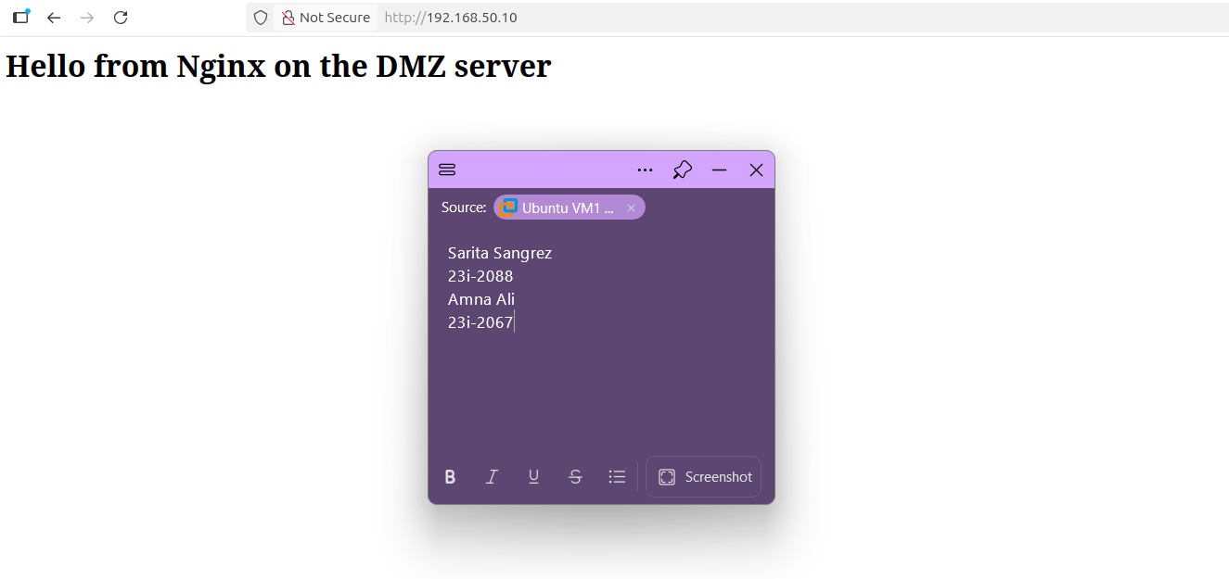

Problems Faced and Resolutions

- No Internet Access after Rule Changes
- Problem: After applying restrictive firewall rules (like “Allow only certain websites”), the LAN client lost internet access completely.
- Cause: The rules were too restrictive, and traffic not explicitly allowed was blocked.
- Solution: Disabled overly strict rules during testing, then re-applied them step by step (DNS, HTTP, HTTPS only to allowed sites).

- Nginx SSL Configuration Error
- Problem: Nginx failed to start when SSL was added directly in the wrong block.
- Cause: The SSL directives (listen 443 ssl, cert/key paths) were placed outside the correct server {} block.
- Solution: Moved the SSL configuration inside the server block and pointed it to the correct certificate and key files.

- Suricata Alerts Not Showing on LAN
- Problem: LAN scans from Kali did not generate any Suricata alerts.
- Cause: No rules triggered on LAN.
- Solution: Created a custom ICMP alert rule, verified alerts appeared, and later enabled specific rule categories (e.g., DNS, Telnet).

- No Captive Portal Redirection on LAN1 (Ubuntu VM)
  - Problem: When connecting to the LAN, the browser didn’t redirect to the pfSense Captive Portal.
  - Cause: The VM was using 8.8.8.8 as its DNS instead of the pfSense LAN IP.
  - Solution: Changed the DNS server on the VM to the pfSense LAN IP (192.168.1.1). After that, pfSense could intercept DNS and redirect to the Captive Portal page.

- Kali VM on DHCP Not Showing Captive Portal
  - Problem: The Kali client on DHCP didn’t get the Captive Portal login.
  - Cause: systemd-resolved wasn’t working correctly, so DNS queries weren’t being handled by pfSense.
  - Solution: Disabled the stub resolver and manually set the DNS to pfSense (192.168.1.1). Then the Captive Portal login appeared.

- Nginx Not Showing Expected Page (Apache Page Appeared Instead)
  - Problem: Even though Nginx was installed and running, accessing the server showed the Apache2 Debian Default Page.
  - Cause: The default HTML file from Apache was still in /var/www/html/, and Nginx was serving it.
  - Solution: Stopped and disabled Apache, then replaced /var/www/html/index.html with a custom test page for Nginx. After that, the page displayed correctly.

